Gaming makes kids physically fit? New research says yes. Maybe.
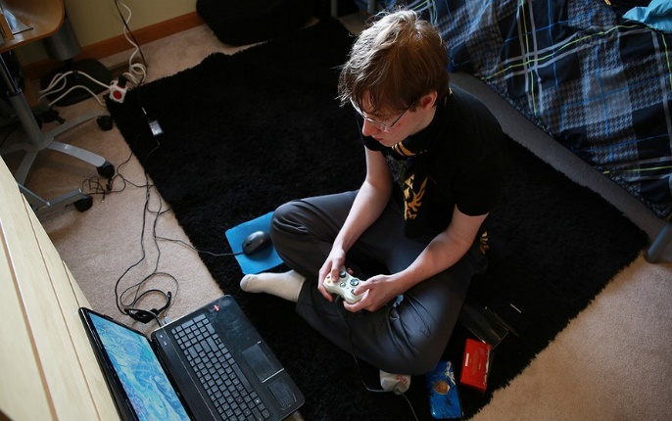
By Chicago Tribune, adapted by Newsela staff / 02.04.15
CHICAGO — Imagine a hardcore video game fanatic, and you probably wouldn't picture Roman Rivera.
He grew up captivated by games from “Pokemon” to “Call of Duty,” and evaded his mom’s screen-time limits by secretly playing his Game Boy after bedtime. Now that he’s 21, he spends up to four hours a day battling enemies in the virtual arena of “Dota 2.”
Yet he was an honor student and a member of the debate team at Downers Grove North High School outside of Chicago, and today he is studying economics at the University of Chicago. These accomplishments did not come in spite of gaming, but because of it, Rivera said.

Gaming Is Here to Stay
Rivera said that video games have broadened his interests and improved his mental agility. “Without a doubt they have benefited me.”
Rivera may be right. A new wave of research has found surprising advantages in an activity that many dismiss as a waste of time, if not an outright menace. Social scientists have recently linked gaming with enhanced mental skills, moral decision-making and even physical fitness.
“We’re working really hard on understanding what aspects of gaming could be leveraged for the betterment of society,” said Daphne Bavelier. She is a neuroscientist who researches video games at the University of Geneva in Switzerland and the University of Rochester in New York. “Everyone understands it’s here to stay. It’s not going to disappear. You could try to ban it, but it seems to have really interesting positive effects.”
Researchers have done thousands of studies on gaming since the 1980s, often with clearly negative results. Some associated video games with an increased risk of epileptic seizures, while others warned that gaming could cause dangerously elevated heart rates. Many studies also linked violent games to aggression and anti-social behavior.

New Study, New Results
When a new generation of scientists more familiar with a technology comes along, different results often appear in studies, said Christopher Ferguson, a psychology professor at Stetson University in Florida. "And that’s what is happening with gaming."
Ferguson has consistently found that violent video games do not contribute to aggression in kids. One recent project actually concluded that some children who play violent games are less likely than others to be bullies.
He speculates that kids use video games to relieve strong emotions. Because they are busy playing video games, "they don’t have time to bully other kids,” he said.
Another take on video game violence came from University of Buffalo communications professor Matthew Grizzard.
He found that those who played the bad guy role in shooter games often felt guilty.
"Games can be this really important tool for teaching people what the right decisions might be," he said. "Maybe one way to do that is showing what the consequences of wrong decisions would be.”

No Time for Snacks
Gaming has long been blamed in the growing epidemic of obesity, but Professor Chennan Liu's research suggests it might have gotten a bad rap. She found that those who play video games for an average of three to six hours a day were healthier than those who played less.
Gaming might burn more calories than just watching TV or it may be that kids holding a controller are not as likely to pick up a snack or a soda.
That theory made sense to Dan Wojtowicz, 18, a student at Andrew High School in Tinley Park, Illinois. He spends up to seven hours a day on “StarCraft II,” “League of Legends” and other games.
“When I go on long gaming streaks, many times I don’t feel the need to eat as much, even though it takes a lot of my energy,” he said. “I can go without eating for three to four hours.”

Surgeon in Training?
The most intriguing studies might be coming from neuroscientists, who are learning how gaming affects the brain. Simone Kuhn, a researcher at the Max Planck Institute for Human Development in Berlin, has found that the brain's prefrontal cortex, which is linked to a person's personality and decision-making, actually grows thicker and gray matter expands in people who play games. These changes could improve memory and navigational ability.
Bavelier has found that first-person shooters — one of the most hated categories of video games — can help improve vision and attention span.
Bavelier noted that young gamers who become surgeons perform faster and make fewer errors than more experienced surgeons.

Of Course There Are Doubters
Not everyone is sold on the idea that gaming is good for you. Joseph Bisoglio, who has studied the subject at Columbia University Medical Center in New York, said that studies generally do not compare gaming with other activities that exercise the brain. Learning a new language or a musical instrument may have a better effect on the brain than gaming, he said.
Doug Bakshis doubted the value of video games when his son Noah began to play “Minecraft” and other games for hours at a time. But then Noah, who has Asperger’s syndrome, a disability that affects social skills, started becoming more open to the world.
Noah, now 15, said gaming has expanded his interests. He is studying archery and Japanese culture after encountering them in video games. His attention, focus and coordination have also improved, he said, as has his self-awareness.
“(Games) helped me discover what my inner ethics are, what choices I would make in particular situations,” he said. “What I’ve found is I generally try to resolve things peacefully.
"You can grow emotional attachment to the characters, and that’s not a bad thing," he said.

